# Brainstorm

**TIP**

Add customizable tags to sticky notes to make it easier to find, browse, organize, and categorize important ideas as themes within your mural.

**TIP**

You can select a sticky note and hit the pencil [switch to sketch] icon to start drawing!

### Before you collaborate

#### A little bit of preparation goes a long way with this session. Here’s what you need to do to get going.

##### 10 minutes

**1**

### Define your problem statement

#### What problem are you trying to solve? Frame your problem as a How Might We statement. This will be the focus of your brainstorm.

##### 5 minutes

**2**

### Brainstorm

#### Write down any ideas that come to mind that address your problem statement.

##### 10 minutes

**3**

### Group ideas

#### Take turns sharing your ideas while clustering similar or related notes as you go. In the last 10 minutes, give each cluster a sentence-like label. If a cluster is bigger than six sticky notes, try and see if you and break it up into smaller sub-groups.

##### 20 minutes

**4**

### Prioritize

#### Your team should all be on the same page about what's important moving forward. Place your ideas on this grid to determine which ideas are important and which are feasible.

**20 minutes**

### After you collaborate

You can export the mural as an image or pdf to share with members of your company who might find it helpful.

# & idea prioritization

Use this template in your own brainstorming sessions so your team can unleash their imagination and start shaping concepts even if you're not sitting in the same room.

**10 minutes** to prepare

**1 hour** to collaborate

**2-8 people** recommended

###### Team gathering

Define who should participate in the session and send an invite. Share relevant information or pre-work ahead.

###### Set the goal

Think about the problem you'll be focusing on solving in the brainstorming session.

###### Learn how to use the facilitation tools

Use the Facilitation Superpowers to run a happy and productive session.

[**Open article**](https://support.mural.co/en/articles/2113740-facilitation-superpowers)

**PROBLEM**

How might we detect active drowning in swimming pool and save people's life with the help of lifeguards?

**Key rules of brainstorming**

Cameras and alarms should be maintained in proper condition

Camera should capture the drowning of a person with no time delay

To run an smooth and productive session

People with health issues should be prioritized while saving

Alarm's sound be checked for its loudness and duration of play

Camera should be in good condition so that it captures active drowning without fail

**Krishna kumar S**

On hearing the alarm , lifeguard should rescue the person without delay

Cameras and alarms should be maintained in proper condition

Issues arising in cameras and alarms should be resolved quickly

Well trained lifeguards should be appointed for effective guarding

###### Kamesh H

**Camera**

Camera should capture the drowning of a person with no time delay

The installation of camera should be economical

Installation of camera to monitor the person in the pool

Issues arising in cameras and alarms should be resolved quickly

Camera should be in good condition so that it captures active drowning without fail

**Emergency**

Alerting the family through the details given by the person who is drowning

## 

prioritize people with health issues while saving

If time passes and still the person is not saved,then another life gaurd should be alerted

Camera should be in good condition so that it captures active drowning without fail

updation of software with any forms should be possible

process mechanism for detecting incident should be prevent

Different alarm sounds should be allotted for various group of people

## 

notification of the drowning incident to the lifeguard through alarm

On hearing the alarm , lifeguard should rescue the person without delay

Installation of camera to monitor the person in the pool

Alerting the family through the details given by the person who is drowning

constant monitoring to prevent drowning

prioritize people with health issues while saving

Alerting the family through the details given by the person who is drowning

### Quick add-ons

###### Share the mural

**Share a view link** to the mural with stakeholders to keep them in the loop about the outcomes of the session.

###### Export the mural

Export a copy of the mural as a PNG or PDF to attach to emails, include in slides, or save in your drive.

### Keep moving forward

###### Strategy blueprint

Define the components of a new idea or strategy.

###### [Open the template](https://app.mural.co/template/e95f612a-f72a-4772-bc48-545aaa04e0c9/984865a6-0a96-4472-a48d-47639307b3ca)

**Customer experience journey map**

Stay in topic.

Defer judgment.

Encourage wild ideas.

Listen to others.

###### Alarm

**Software**

### Importance

If each of these

updation of software with any forms should be possible

Understand customer needs, motivations, and obstacles for an experience.

[**Open the template**](https://app.mural.co/template/b7114010-3a67-4d63-a51d-6f2cedc9633f/c1b465ab-57af-4624-8faf-ebb312edc0eb)

Issues arising in cameras and alarms should be resolved quickly

software should be maintained in a better way

Setting up of alarm to notify the life gaurd about drowning

lifeguard should indulge in rescuing process on hearing the alarm with no delay in time

Go for volume. If possible, be visual.

prioritize people with health issues while saving

notification of the drowning incident to the lifeguard through alarm

Different alarm sounds should be allotted for various group of people

**Subash V**

updation of software with any forms should be possible

accurate detection of the swimmer should be present

installation of camera to monitor the person in the pool

constant monitoring to prevent drowning

###### Lifeguard

Alarm's sound be checked for its loudness and duration of play

Setting up of alarm to notify the life gaurd about drowning

Alarm should be turned off by the lifeguard after the completion of rescuing process

Cameras and alarms should be maintained in proper condition

**drowning**

tasks could get done without any difficulty or cost, which would have the most positive impact?

Alerting the family through the details given by the person who is drowning

**TIP**

Participants can use their cursors to point at where sticky notes should go on the grid. The facilitator can confirm the spot by using the laser pointer holding the **H key** on the keyboard.

## 

software should be maintained in a better way

On hearing the alarm , lifeguard should rescue the person without delay

Installation of camera to monitor the person in the pool

Alarm should be turned off by the lifeguard after the completion of rescuing process

Well trained lifeguards should be appointed for effective guarding

If time passes and still the person is not saved,then another life gaurd should be alerted

accurate detection of the swimmer should be present

###### Strengths, weaknesses, opportunities & threats

Identify strengths, weaknesses, opportunities, and threats (SWOT) to develop a plan.

|  |  |
| --- | --- |
|  |  |
|  |  |

###### [Open the template](https://app.mural.co/template/6a062671-89ee-4b76-9409-2603d8b098be/ca270343-1d54-4952-9d8c-fbc303ffd0f2)

[**Share template feedback**](https://muralco.typeform.com/to/CiqaHVat?typeform-source=app.mural.co)

## 

lifeguard should indulge in rescuing process on hearing the alarm with no delay in time

constant monitoring to prevent drowning

[**Share template feedback**](https://muralco.typeform.com/to/CiqaHVat?typeform-source=app.mural.co)

**Feasibility**

Regardless of their importance, which tasks are more feasible than others? (Cost, time, effort, complexity, etc.)

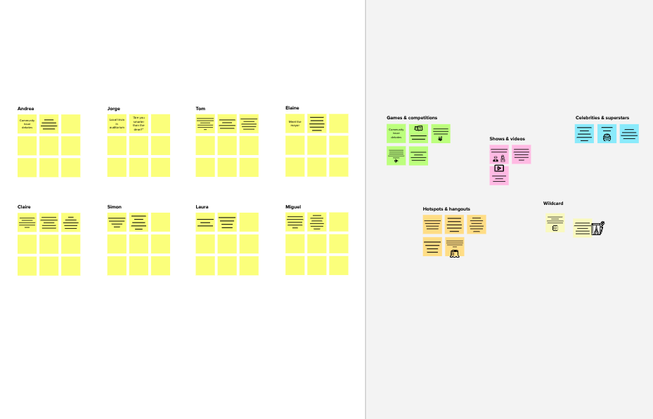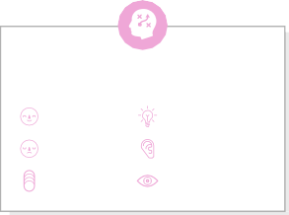

precise mechanism for detecting swimmers should be present

lower maintenance of the installed camera is adequate

alarm should notify the lifeguard as soon as

the drowning person is detected

If time passes and still the person is not saved, then another lifeguard should be alerted

setting up of alarm to notify the lifeguard about drowning

alarm's sound be

checked for its loudness and duration of play

lifeguard should indulge in rescuing process on hearing the alarm with no delay in time

the installation of camera should be economical

Alerting the family through the details given by the person who is drowning

camera should capture the drowning of a person with no time delay

Proper solutions to resolve the issues arising in camera should be present

software should be maintained in a better way

**Template**

**Need some inspiration?**

process mechanism for detecting incident should be prevent

accurate detection of the swimmer should be present

notification of the drowning incident to the lifeguard through alarm

Well trained lifeguards should be appointed for effective guarding

See a finished version of this template to kickstart your work.

[**Open example**](https://app.mural.co/template/e5a93b7b-49f2-48c9-afd7-a635d860eba6/93f1b98d-b2d2-4695-8e85-7e9c0d2fd9b9)